### **CHAPTER 1: INTRODUCTION**

## Background

In this digital world, having an online presence is essential for professionals to showcase their skills and accomplishments. A personal portfolio website is a digital resume, that helps individuals demonstrate their expertise and experience to potential employers, clients, and collaborators. This project aims to develop a portfolio website that efficiently highlights the user’s professional background in a visually appealing and easy-to-navigate format.

## Objectives

* Develop a personal portfolio website that is visually appealing and user-friendly.
* Create a versatile platform for long-term professional growth.
* Provide a digital showcase for professional skills, projects, and achievements.
* Include a dynamic contact form to enable direct communication with potential clients or employers.
* Ensure a responsive design for seamless access across all devices.

## Scope

This project focuses on the development of the core website platform, including design, functionality, and content. It will not cover more advanced features such as backend integrations or complex database functionalities, with the primary focus on showcasing fundamental skills and completed projects. Future updates may involve adding such functionalities based on user feedback and evolving needs.

## Methodology

The development of this portfolio website followed an agile approach, starting with the planning and design phases. Initially, the website structure and design were created using wireframes. The website was then implemented using HTML, CSS, and JavaScript to ensure a responsive and visually appealing interface. Git and GitHub were used for version control to manage the development process and ensure proper tracking of changes. The final phase included comprehensive testing for functionality, responsiveness, and user experience across devices, using browser developer tools and manual testing methods.

### **CHAPTER 2: LITERATURE REVIEW**

## 2.1 Overview of Related Works

Many personal portfolio websites include common sections like ‘About Me’ and ‘Projects,’ which provide a basic overview of an individual’s professional background. However, they often lack interactive features such as dynamic contact forms, which enable real-time communication, or responsive designs that ensure compatibility with various devices. This project aims to address these gaps by creating a clean and visually appealing interface with interactive sections, offering a better user experience compared to traditional portfolio websites**.**

## 2.2 Key Concepts and Definitions

* **Responsive Design**: A design approach that ensures the website layout automatically adjusts to fit screens of various sizes, including mobile phones, tablets, and desktops. This feature is critical to provide users with a seamless browsing experience regardless of the device they use.
* **Dynamic Contact Form**: A website feature that allows users to enter their details and send messages directly through the platform, without requiring external email applications. This interactive element improves user convenience and enhances communication efficiency
* **User-Friendly Design:** A design approach focused on creating an interface that is not only visually appealing but also easy to navigate. This ensures that users can quickly find the information they need and interact with the website intuitively.

### **CHAPTER 3: TECHNOLOGY USED**

## 3.1 Programming Languages and Frameworks

HTML5 was used to structure the content and layout of the website, ensuring a semantic and accessible design. CSS3 was employed to style and visually enhance the website, enabling animations, transitions, and responsive layouts. JavaScript provided interactivity, such as handling user inputs and dynamic updates. Additionally, SCSS (a preprocessor for CSS) streamlined the styling process by introducing variables, nesting, and modularity, making the codebase more efficient and maintainable.

## 3.2 Libraries and Tools

Git was utilized for version control, allowing efficient management and tracking of changes during the project development. GitHub served as the hosting platform for storing and sharing the project code, ensuring seamless collaboration and deployment.

## 3.3 Development Environment

The project was developed using Visual Studio Code, a powerful and versatile IDE. Its features, such as syntax highlighting, debugging tools, and seamless Git integration, significantly enhanced the development experience and productivity.

### **CHAPTER 4: REQUIREMENTS AND SPECIFICATIONS**

## 4.1 Functional Requirements

* The website must display distinct sections such as:
  + **About Me**: A brief overview of the user's professional background.
  + **Projects**: Showcasing completed work with descriptions and visuals.
  + **Contact**: Allowing users to reach out via a dynamic contact form.
* The contact form must enable users to submit their name, email, and message.
* The website must provide navigation links to access all sections seamlessly.

## 4.2 Non-functional Requirements

* The website must be responsive, ensuring compatibility with various screen sizes, including mobile, tablet, and desktop devices.
* The website should load within 3 seconds on a standard internet connection.
* The design must follow a consistent and visually appealing color scheme.
* The website must function correctly across modern browsers such as Chrome, Firefox, and Edge.
* The codebase should maintain readability and modularity, leveraging SCSS for streamlined styling.

## 4.3 System Architecture

* **Frontend**:
  + The website structure is built using **HTML5** for semantic and accessible content.
  + **CSS3** and **SCSS** are used for styling, with SCSS precompiled into CSS for maintainability.
  + **JavaScript** is implemented to handle interactivity and dynamic behavior.
* **Deployment**: The project is hosted on **GitHub Pages**, ensuring easy accessibility and version control integration.
* **Tools**: Development is carried out in **Visual Studio Code**, utilizing its extensions for syntax highlighting, debugging, and Git integration.

### **CHAPTER 5: DESIGN AND IMPLEMENTATION**

## 5.1 User Interface Design

* The user interface (UI) of the portfolio website was designed with a clean, minimalist approach to ensure both aesthetic appeal and usability. The layout follows a single-page design structure with distinct sections like "About Me," "Projects," and "Contact."
* **Color Scheme**: A modern and professional color palette was chosen to reflect the user’s branding.
* **Typography**: The fonts used were clean and easy to read, with headings styled using the POPINS font family for clarity and emphasis.
* **Responsive Design**: The design was made responsive using CSS media queries to ensure compatibility across all devices. This allows the layout to adjust dynamically for mobile, tablet, and desktop devices.

## 5.2 Backend Logic and Data Handling

* While the project is front-end focused, the backend logic involves minimal data handling as no database is used in this portfolio. The main backend logic revolves around the dynamic handling of the contact form.
* **Form Submission**: The contact form uses JavaScript to validate user input (e.g., name, email, message) before submitting the form.
* **No Database**: Since the website does not require persistent data storage, the form data is handled temporarily in the browser. In a real-world scenario, this could be integrated with a backend service to send form data to an email or store it in a database.

## 5.3 Data Structures and Algorithms

* Given the nature of the project, complex data structures or algorithms were not necessary. However, a few simple data-handling mechanisms were implemented:
* **JavaScript Functions**: Basic functions were used to handle form validation and ensure the input meets the required format before submission.
* **Event Listeners**: Event listeners in JavaScript are used to track user interactions, such as clicking the submit button or filling out the contact form fields.

## 5.4 Input Validation and Error Handling

* Input validation and error handling are crucial to ensure data integrity and enhance user experience. For this project, JavaScript was used to validate user inputs in the contact form.
* **Validation**: The form checks for valid email addresses and ensures that all required fields (name, email, and message) are filled out before submission.
* **Error Handling**: If there is an issue with the input (e.g., an invalid email or missing field), an error message is displayed to the user, guiding them to correct the problem. Error messages are shown dynamically without refreshing the page.

## 

### **CHAPTER 6: FEATURES AND FUNCTIONALITIES**

## 6.1 Viewing Projects

The 'Projects' section of the website is designed for easy navigation. When hovering over a project, visitors can see the project name and a link to its GitHub repository. This minimalist interaction ensures a clean interface while directing visitors to detailed information about the project hosted on GitHub.

## 6.2 Managing Portfolio Content

The content, such as projects and achievements, is managed manually by updating the HTML and CSS files. This method ensures flexibility in content management, allowing the user to make quick updates or add new projects as needed. In the future, integrating a content management system (CMS) could simplify this process, enabling easier updates without requiring code modifications.

## 6.3 Enhancements and Future Scope

Future updates for this project may include the integration of a backend system for the contact form, allowing messages to be stored in a database or sent directly to an email. Additionally, features such as a blog section can be introduced to share insights, updates, or ongoing projects. These enhancements would increase interactivity and maintain the portfolio’s relevance over time.

### **CHAPTER 7: TESTING AND VALIDATION**

## 7.1 Test Cases and Scenarios

Testing was conducted to ensure that the website functions properly and provides a seamless user experience. The following key tests were performed:

* **Contact Form Test**: Verified that the form collects user data (name, email, message) and displays appropriate error messages when required fields are not filled.
* **Responsiveness Test**: Tested the website on multiple devices, including mobile phones, tablets, and desktops, to ensure the layout adapts accordingly.
* **Navigation Test**: Checked all navigation links, ensuring that clicking on sections like "About Me," "Projects," and "Contact" correctly scrolls the page to the respective section.

## 7.2 Test Results and Analysis

All tests passed successfully:

* The **contact form** worked as expected, collecting the user's input and providing error messages if any required fields were left blank or improperly formatted.
* The **responsive design** was tested across different screen sizes, and the layout was adjusted properly on mobile, tablet, and desktop devices.
* The **navigation** functioned smoothly, with all links redirecting users to the correct sections on the page.

### **CHAPTER 8: RESULTS AND DISCUSSION**

## 8.1 Overview of the Project Outcomes

The development of the personal portfolio website was completed. The website now serves as a professional platform to showcase skills, projects, and achievements. The project was tested thoroughly, ensuring it functions correctly on various devices and browsers. All core features, including the contact form, project sections, and responsiveness, were implemented and tested as planned. The portfolio is fully responsive, adapting seamlessly to mobile, tablet, and desktop screens.

## 8.2 Comparison with Objectives

The main objectives of this project were to create a visually appealing, user-friendly portfolio website that effectively showcases professional skills and accomplishments. These goals were successfully achieved:

* The **design** of the website is clean, modern, and user-friendly, ensuring a positive user experience.
* The **contact form** functions properly, collecting information from users and displaying error messages when needed.
* The website is **responsive**, providing an optimal viewing experience across a range of devices.
* The **projects section** successfully displays and organizes the user’s work, allowing easy access for potential employers or clients.

## 8.3 Lessons Learned and Challenges Faced

During the project, several challenges were encountered and valuable lessons were learned:

* **Challenge**: Ensuring the website was responsive across all devices was more difficult than anticipated. Fine-tuning the layout using media queries took time, especially to make sure all elements aligned properly.
  + **Lesson Learned**: I gained a deeper understanding of responsive design and how to use CSS to make websites adapt to various screen sizes.
* **Challenge**: Adding the dynamic contact form and ensuring it validated inputs correctly posed some issues, particularly with email validation.
  + **Lesson Learned**: I learned how to use JavaScript effectively for input validation and to improve user experience by providing clear error messages.
* **Challenge**: Managing content manually through HTML files proved to be time-consuming as the portfolio expanded.
  + **Lesson Learned**: I realized the importance of considering a content management system (CMS) for more efficient management as the project grows.

### **CHAPTER 9: CODE**

* **9.1 INDEX.HTML**

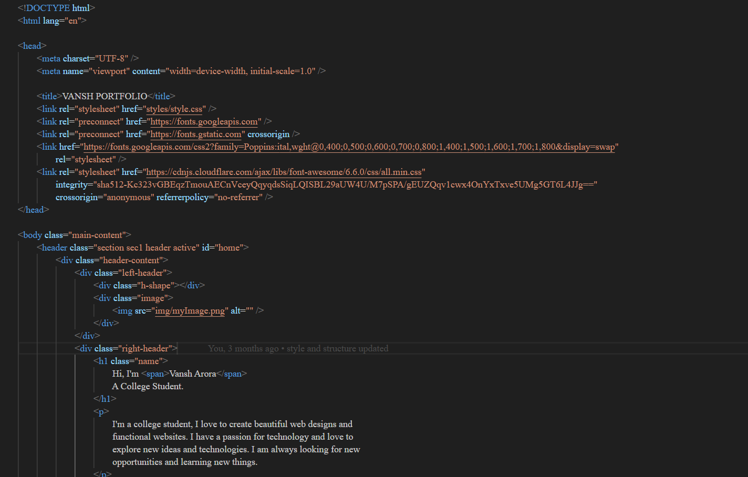

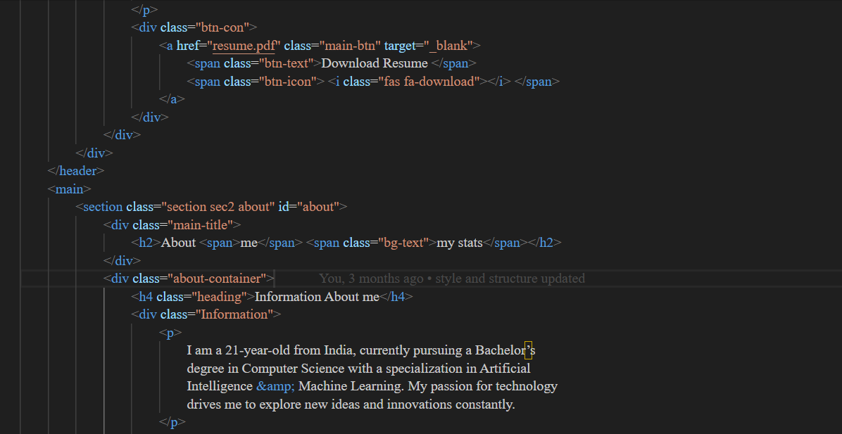

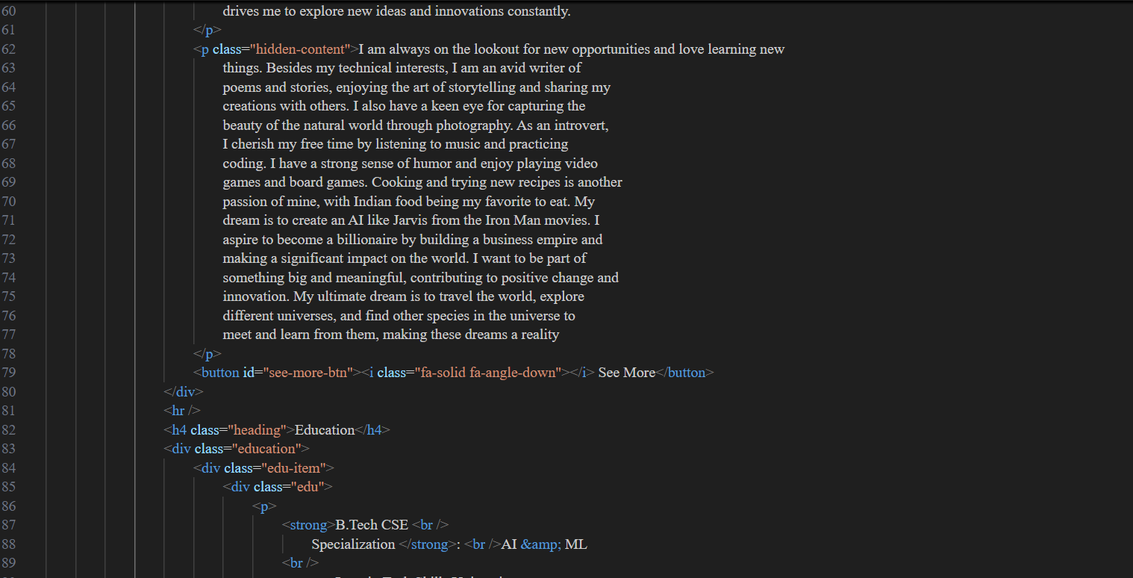

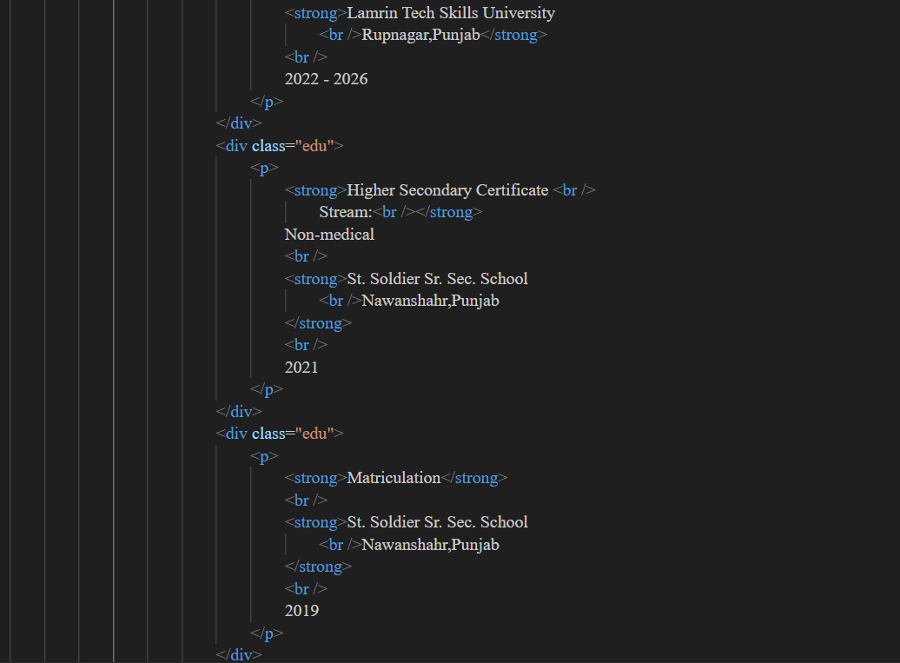

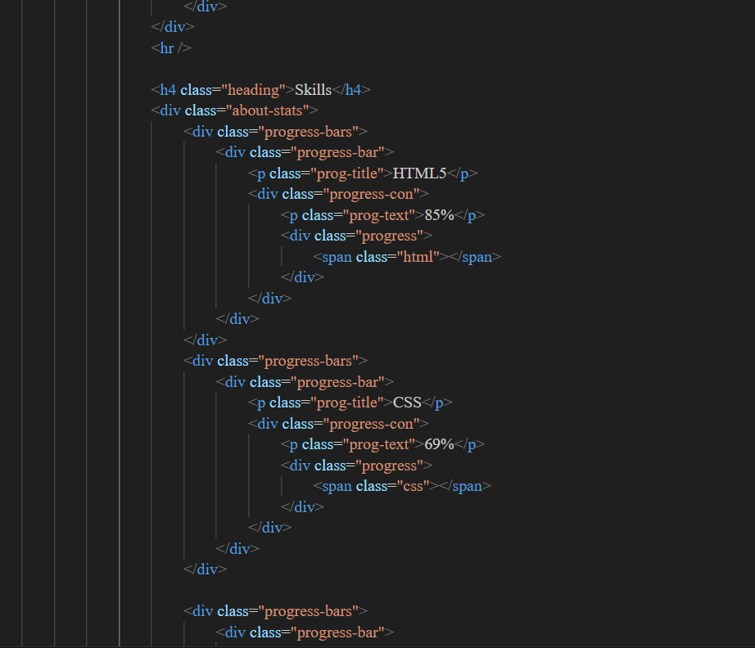

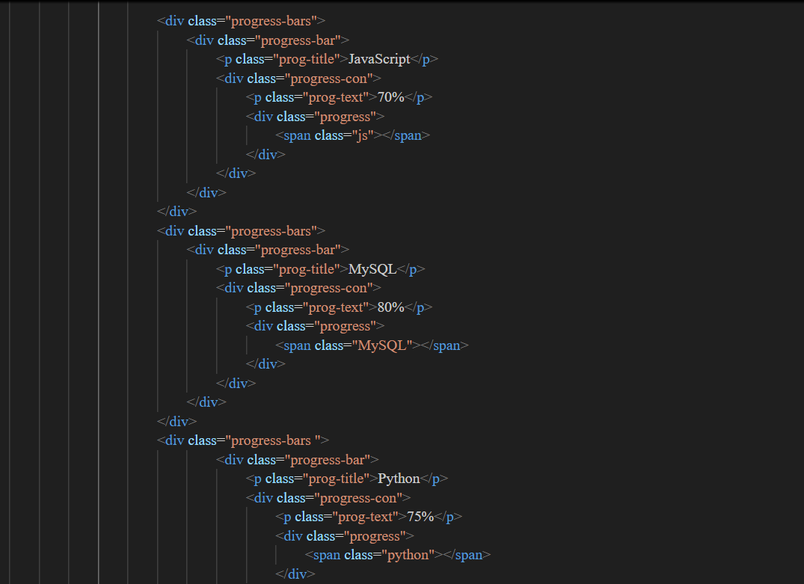

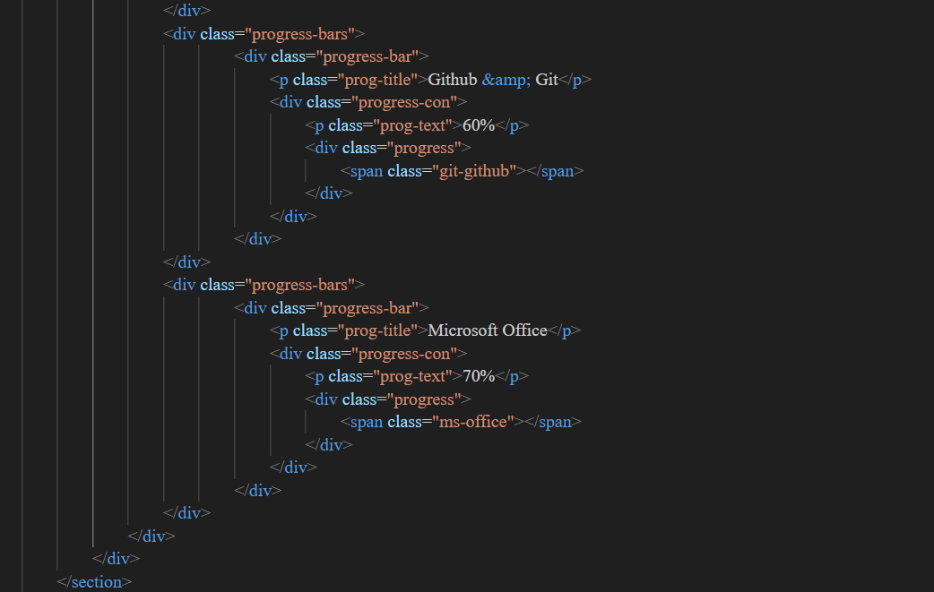

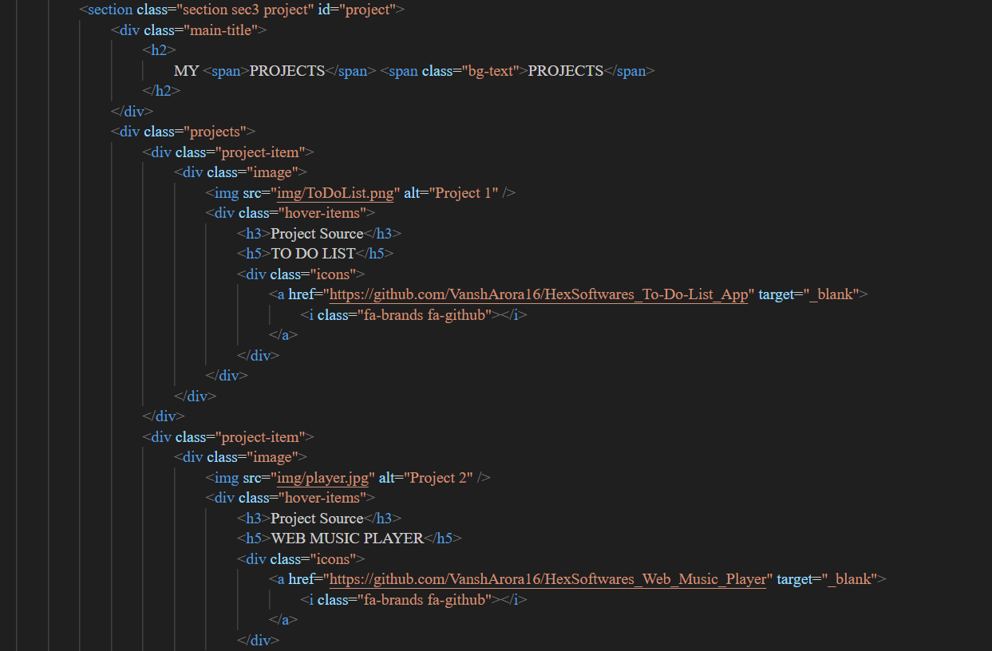

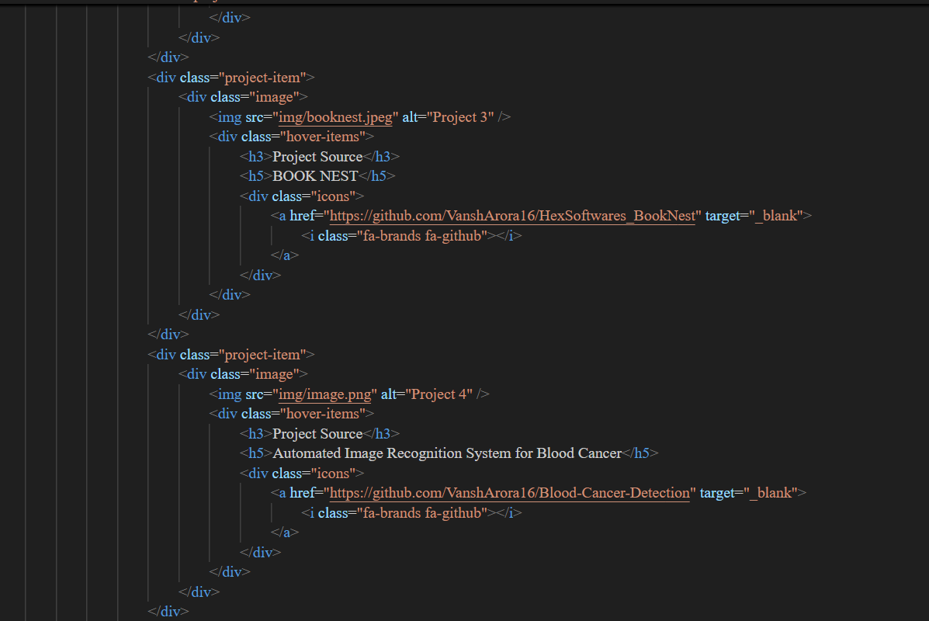

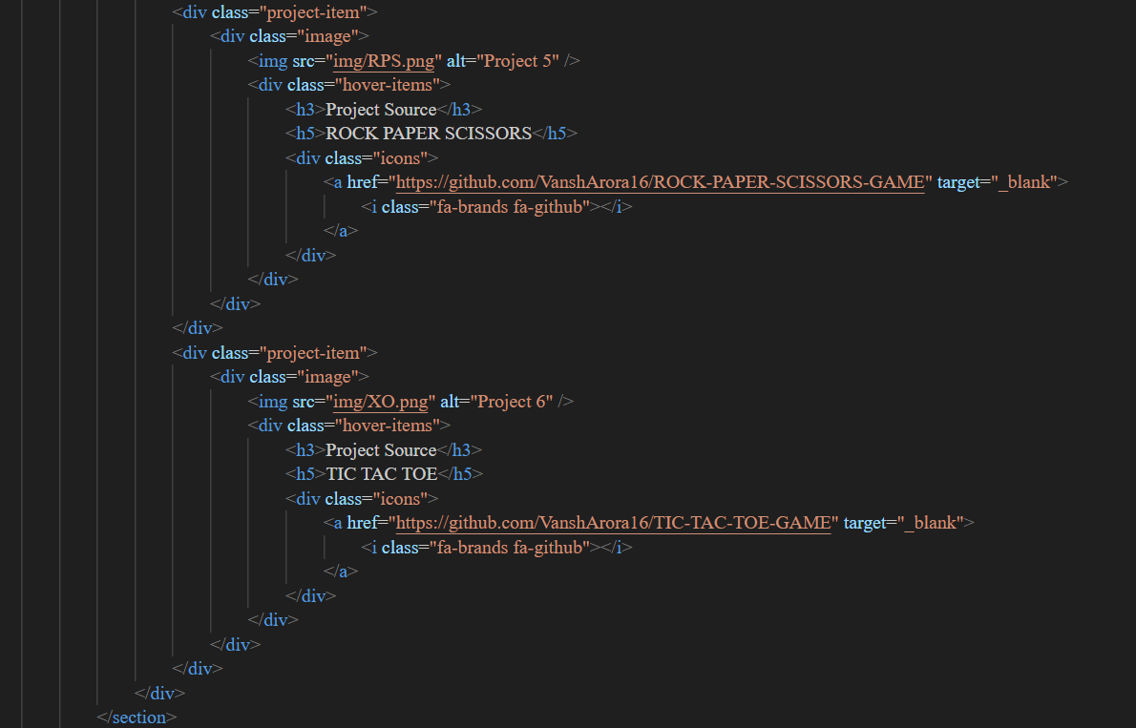

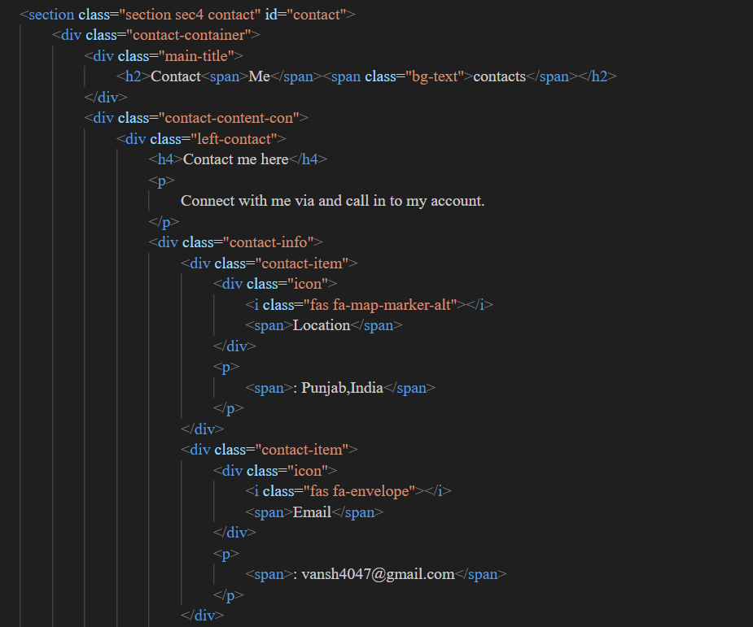

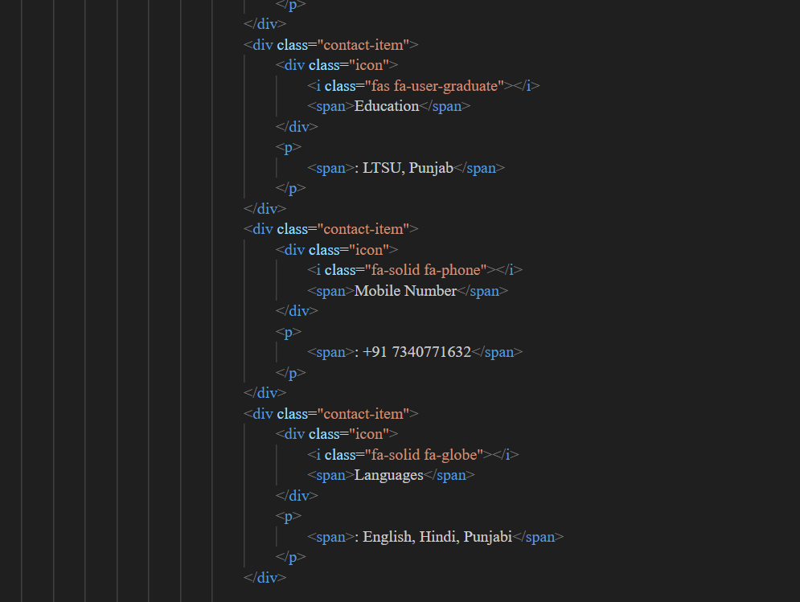

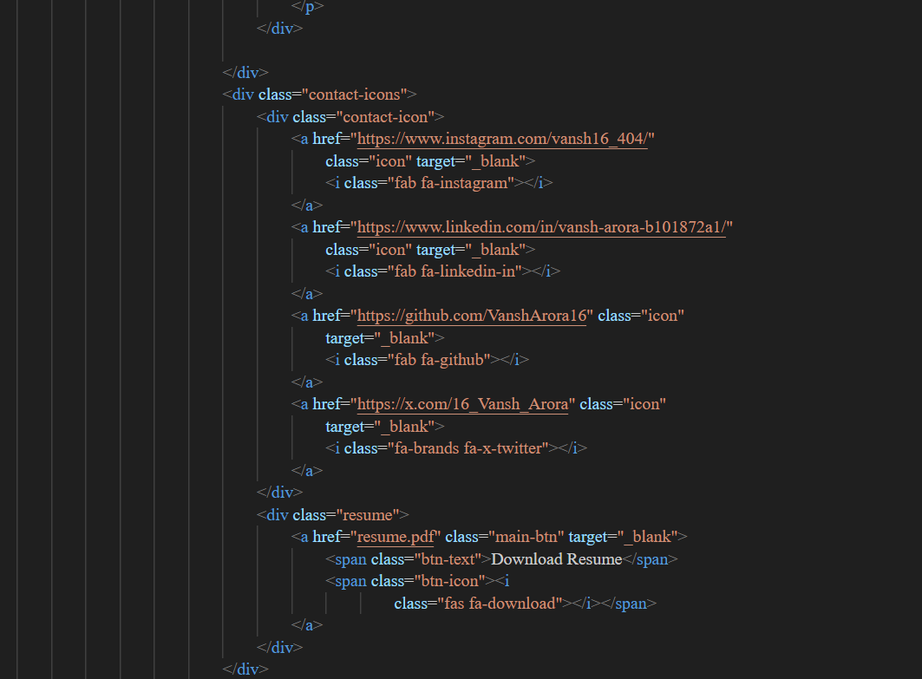

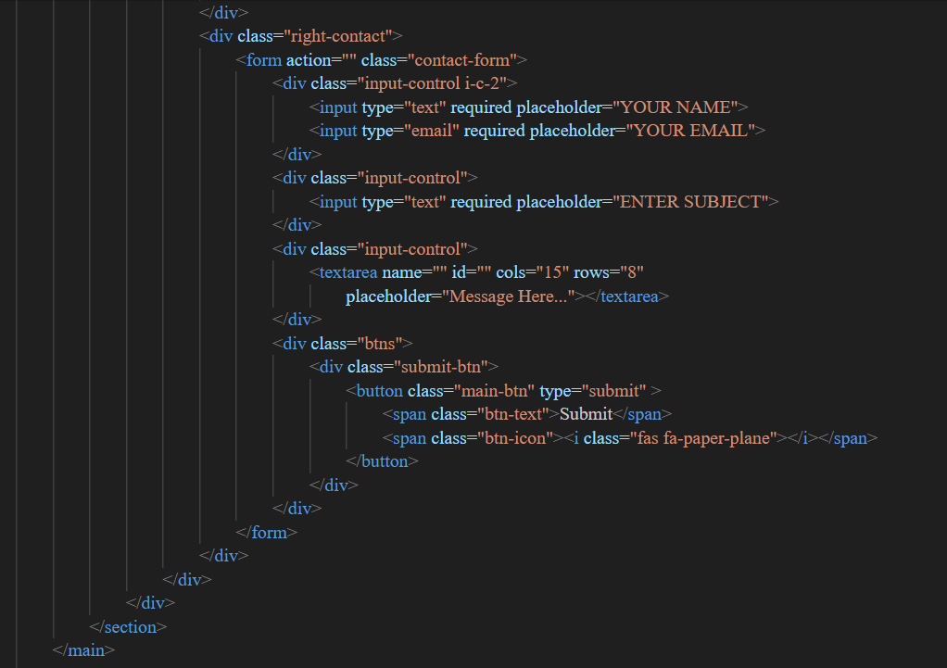

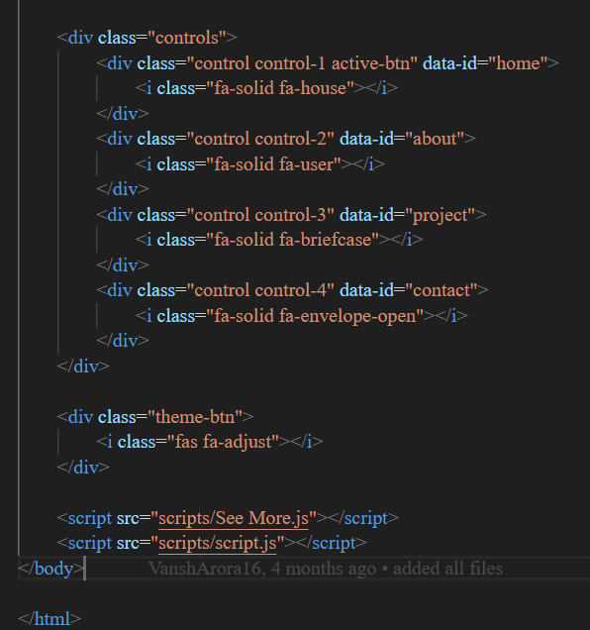

* **9.2 STYLE.CSS**

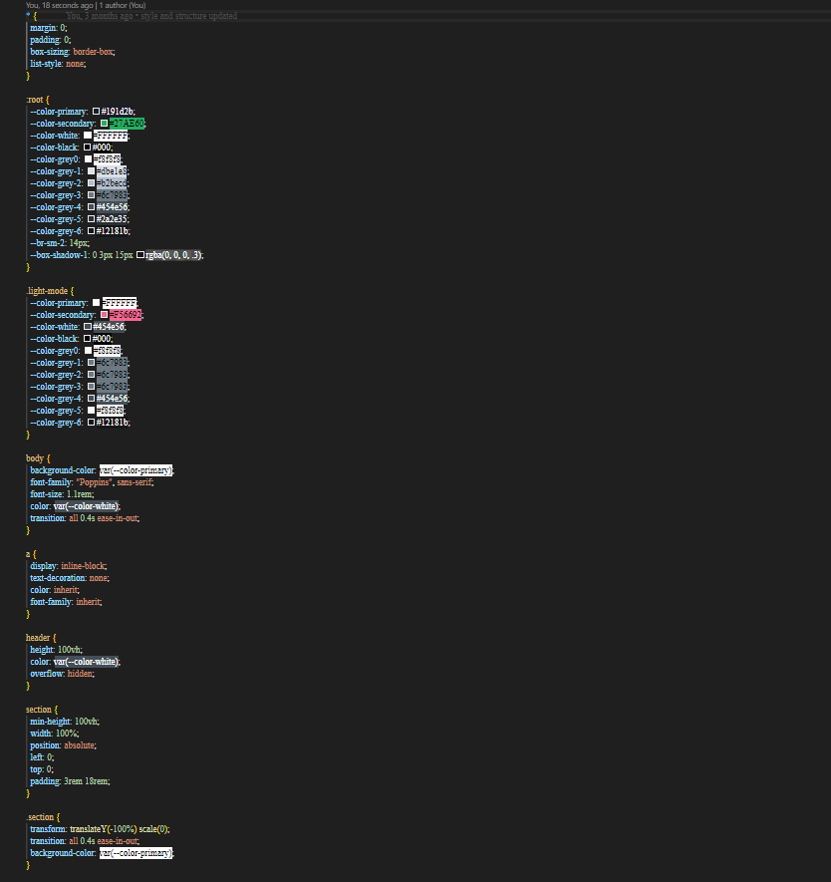

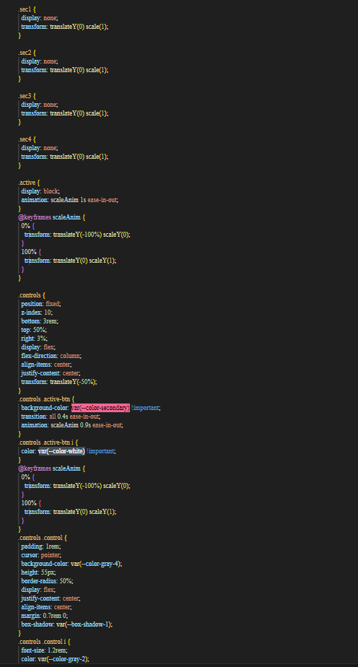

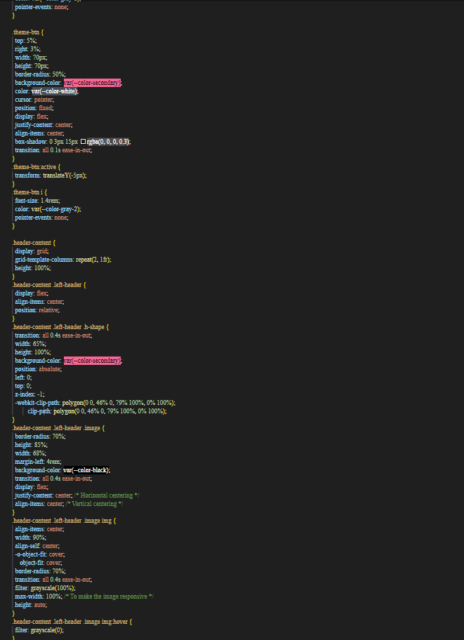

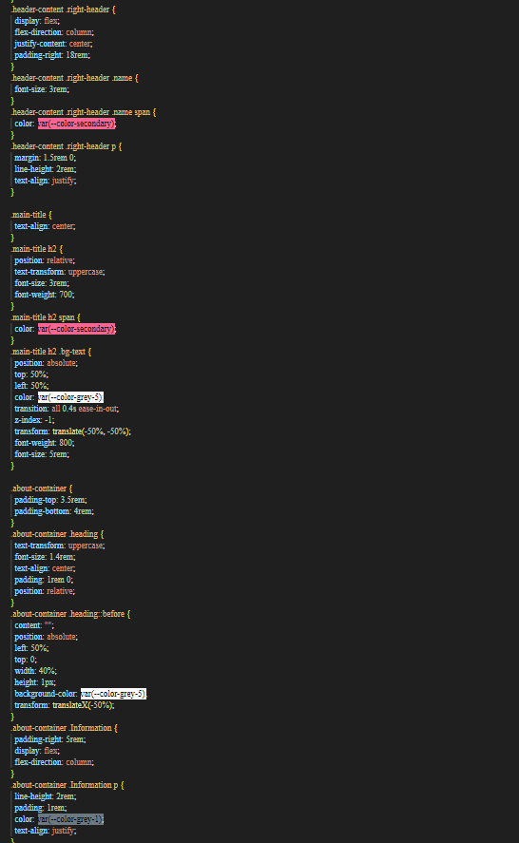

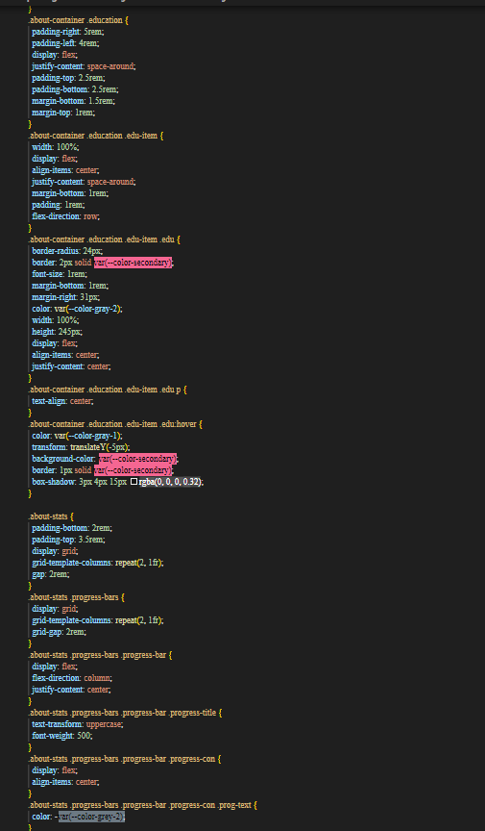

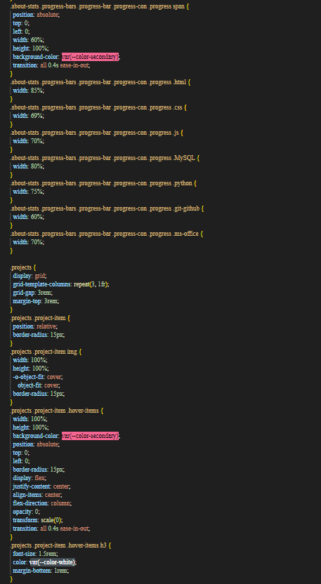

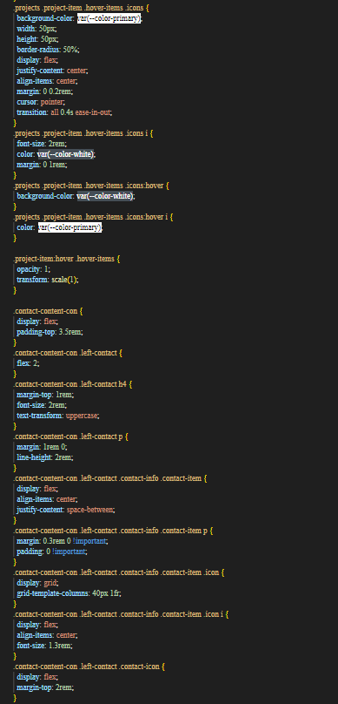

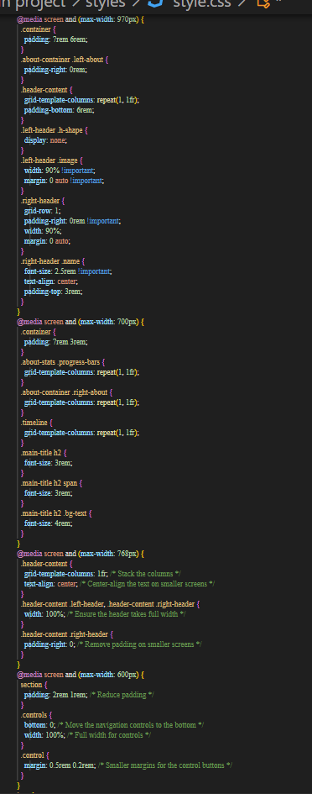

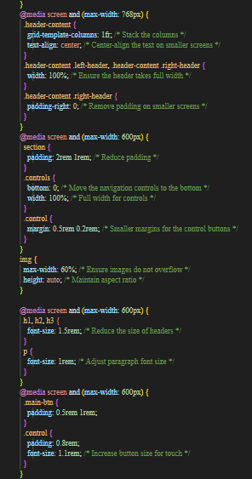

* **9.3 SEE MORE.JS**

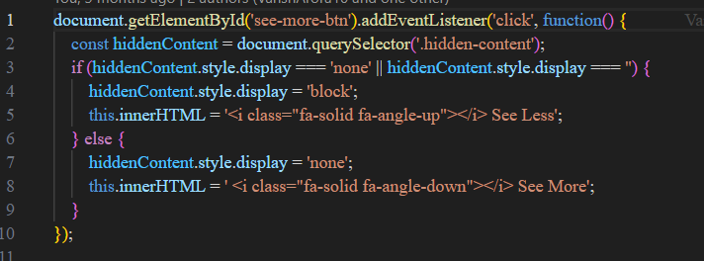

* **9.4 SCRIPT.JS**

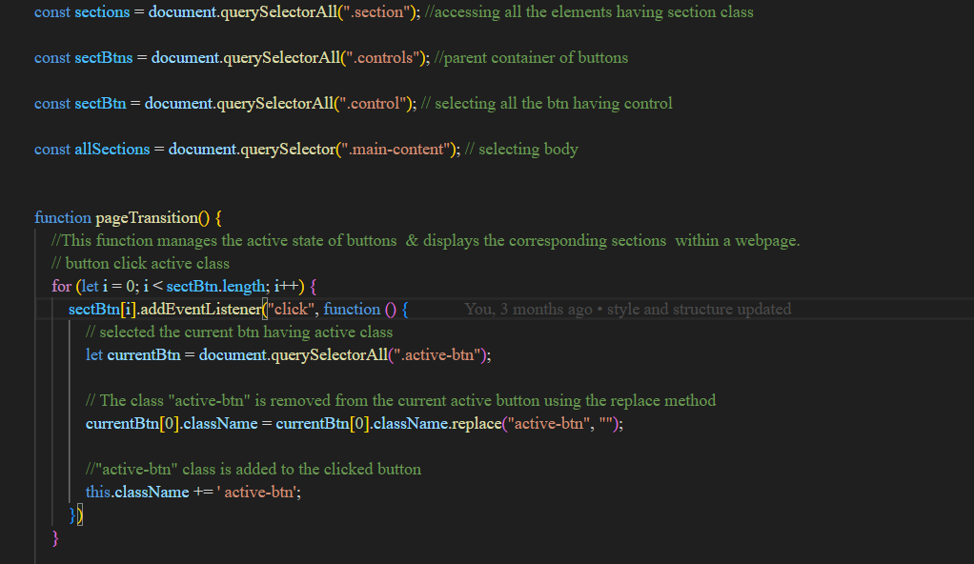

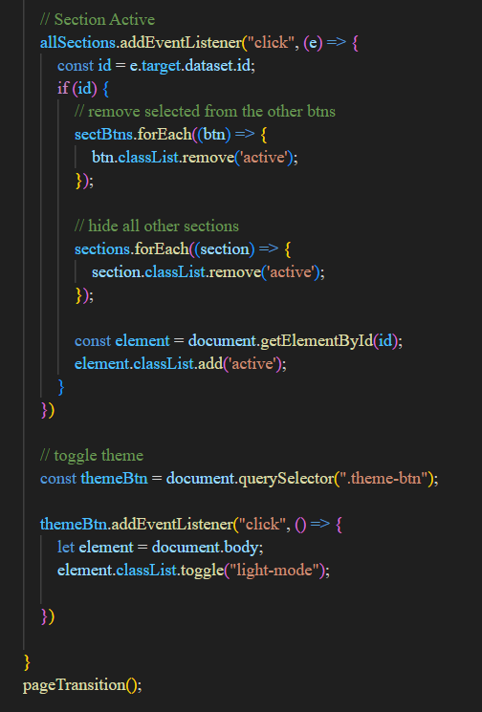

### **CHAPTER 10: SCREENSHOT OF PORTFOLIO WEBSITE**

## HOME PAGE:

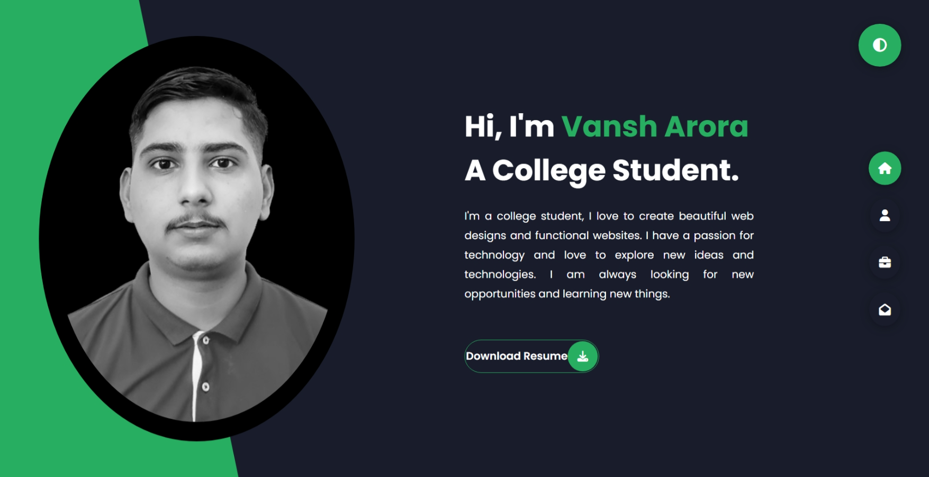

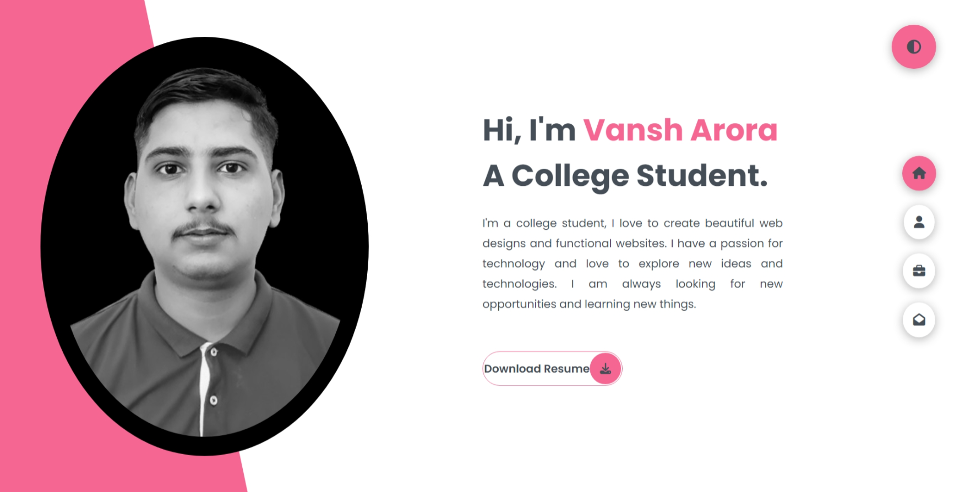

## ABOUT PAGE:

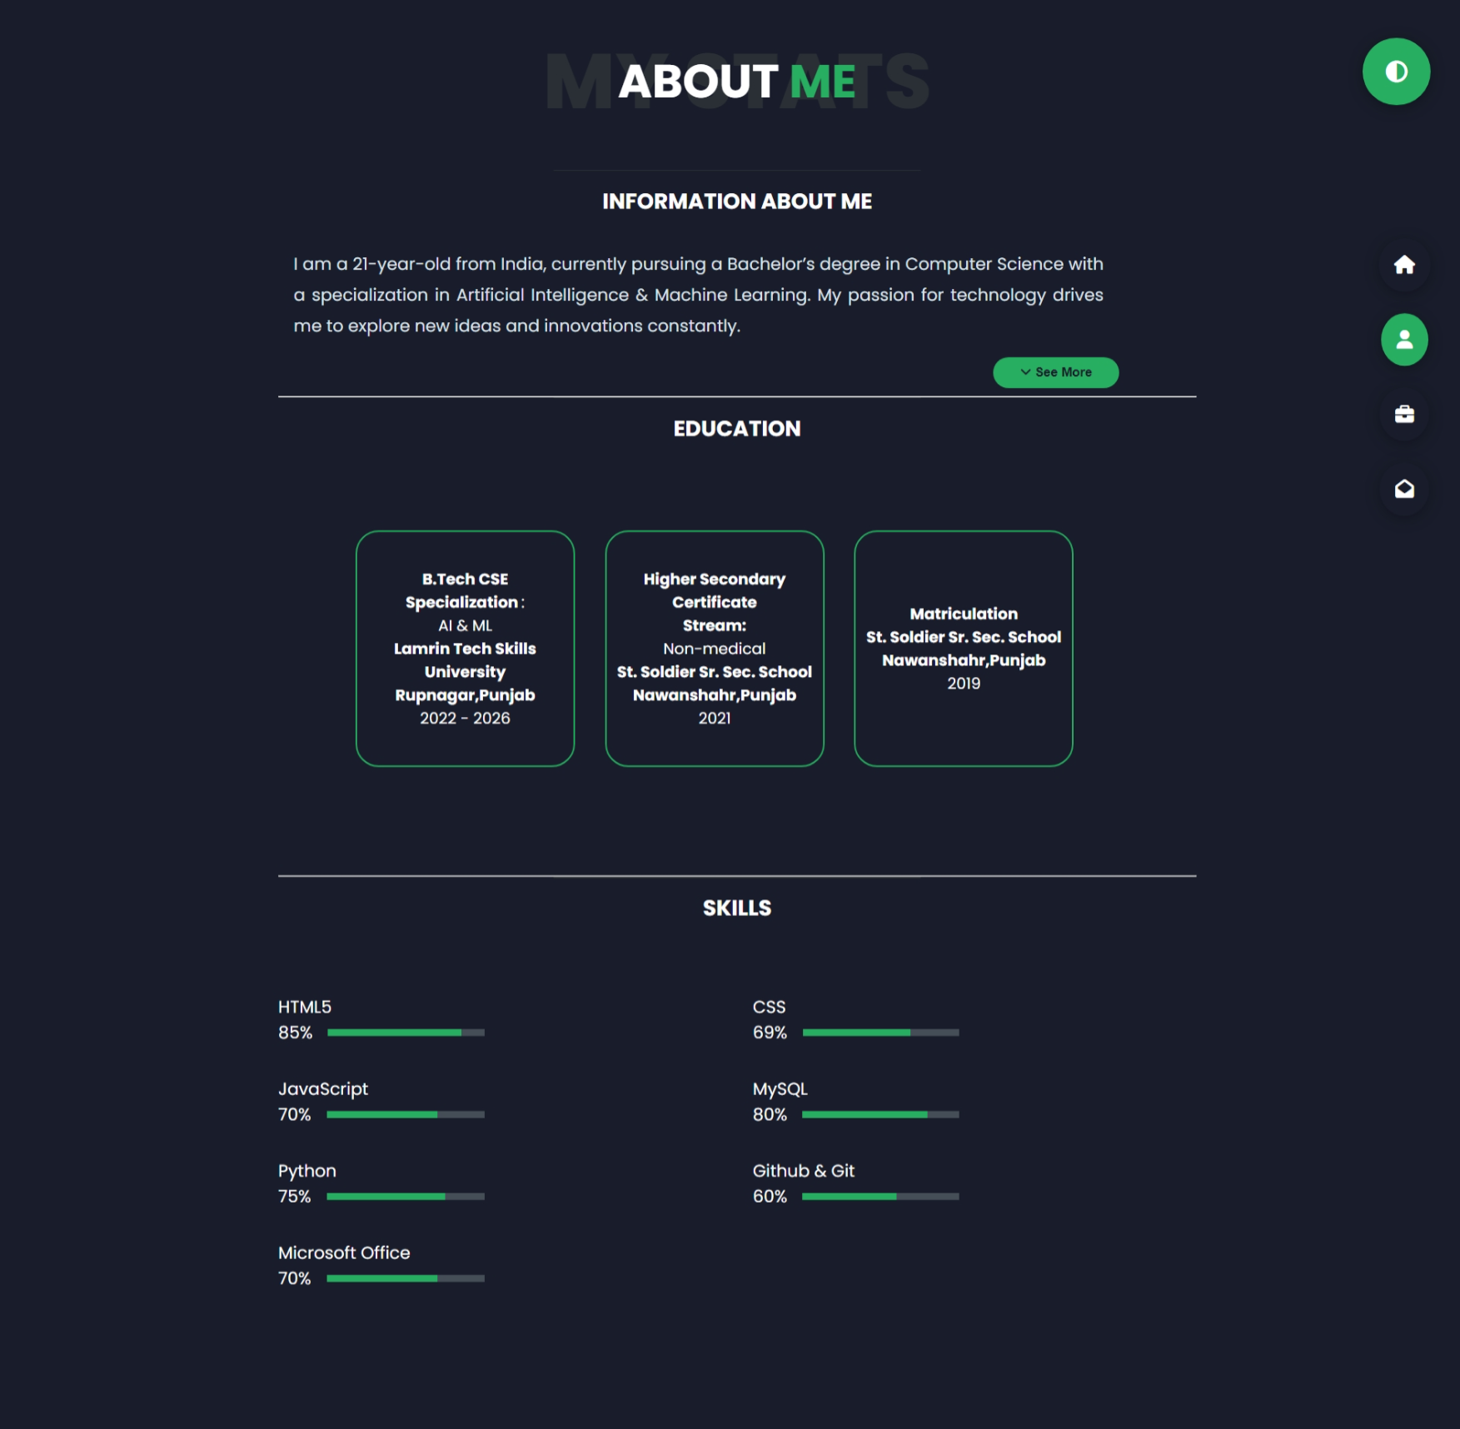

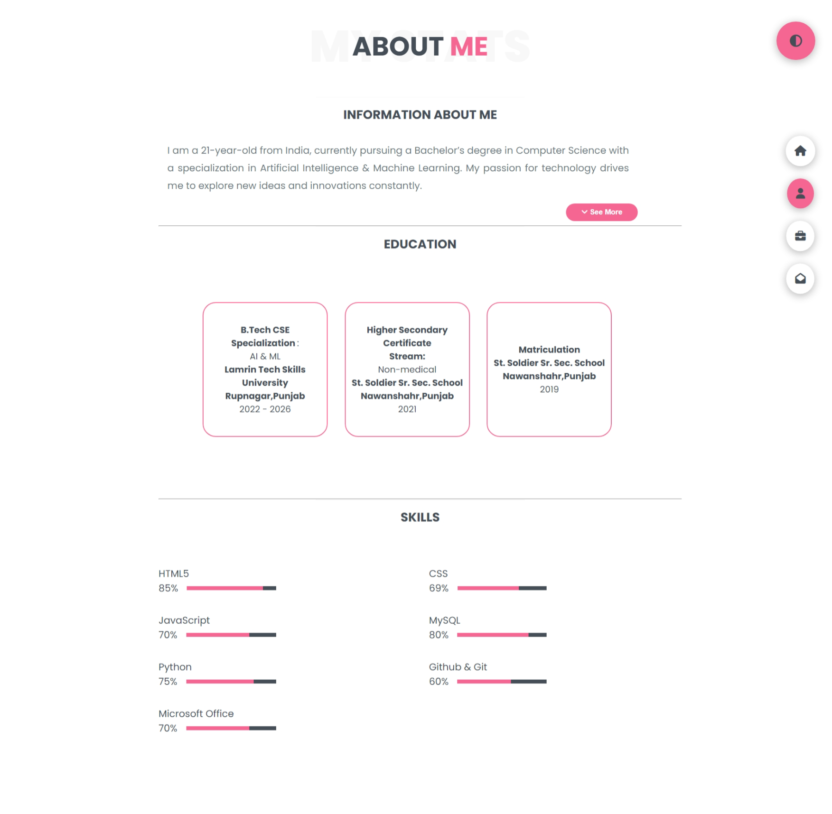

## PROJECT PAGE

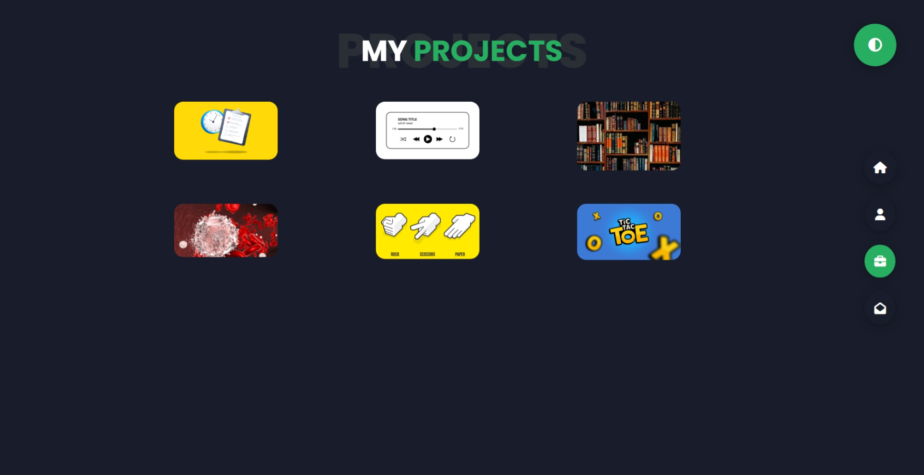

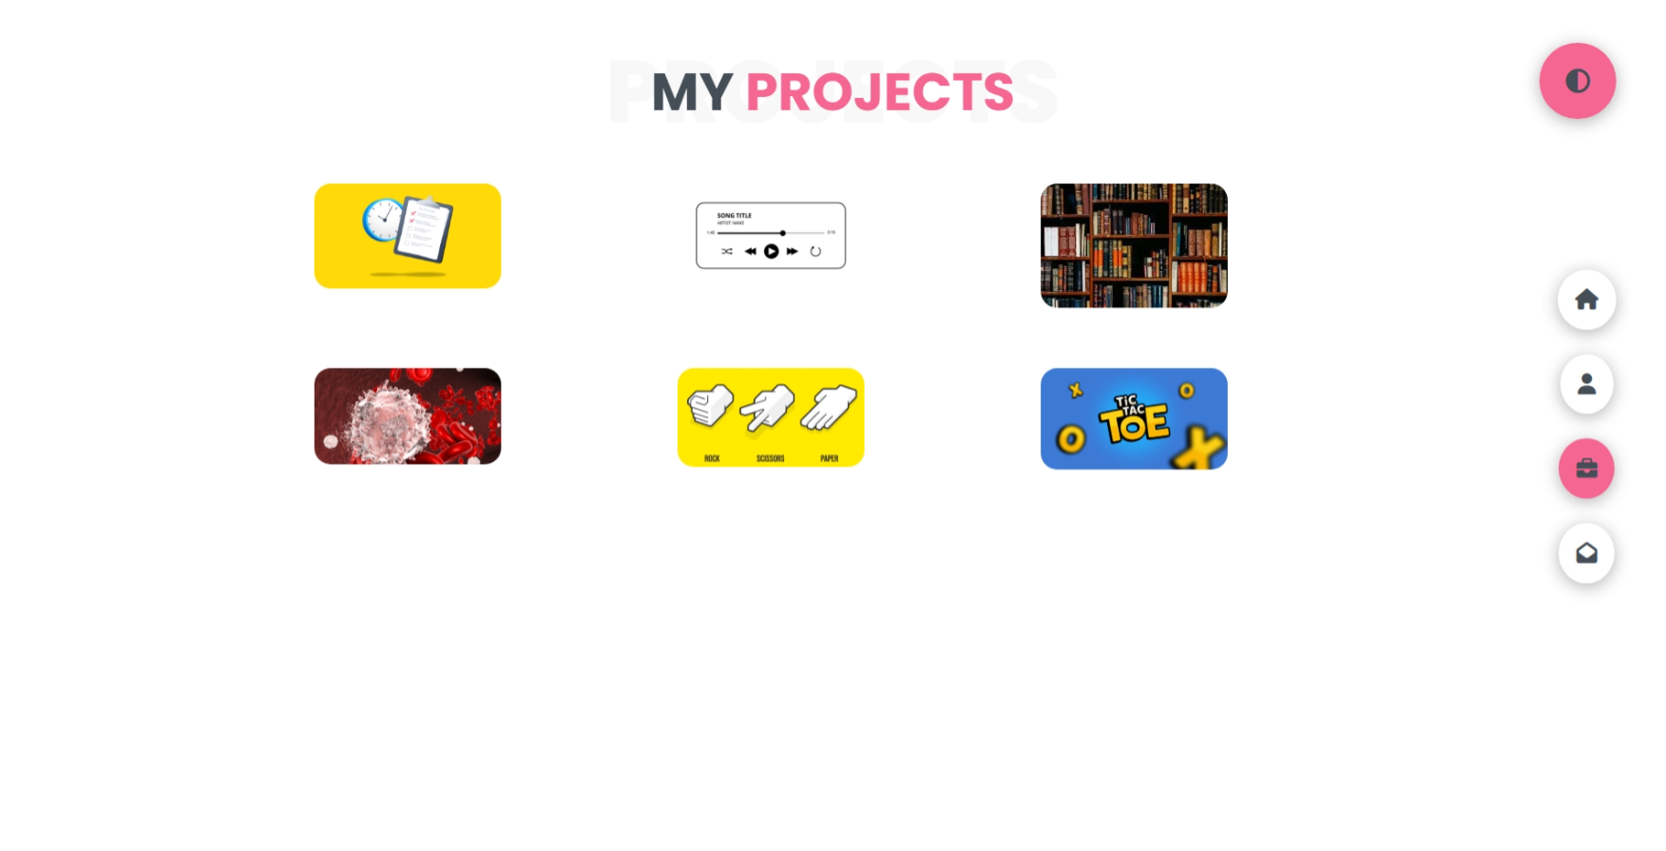

## CONTACT PAGE

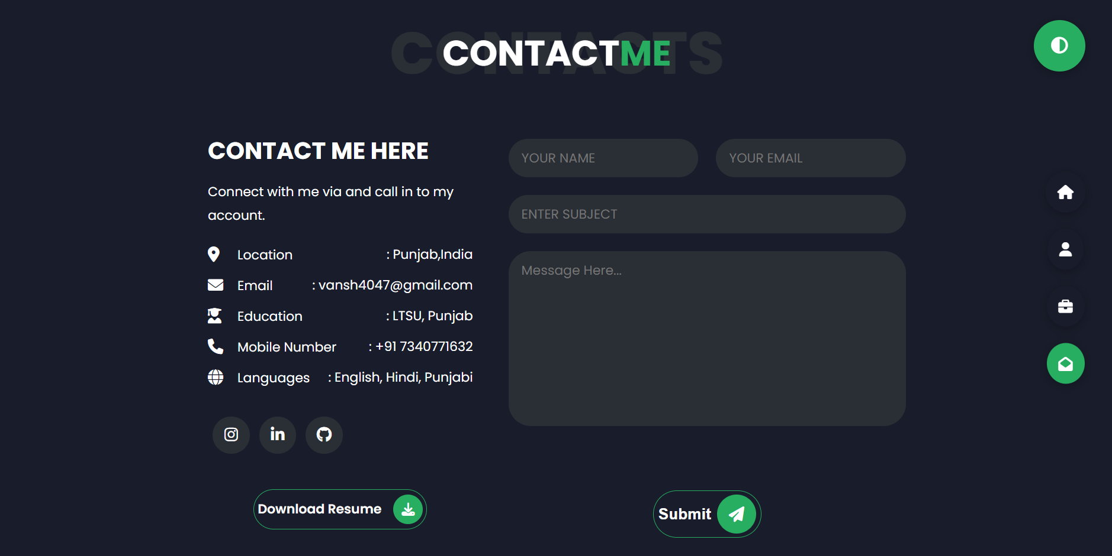

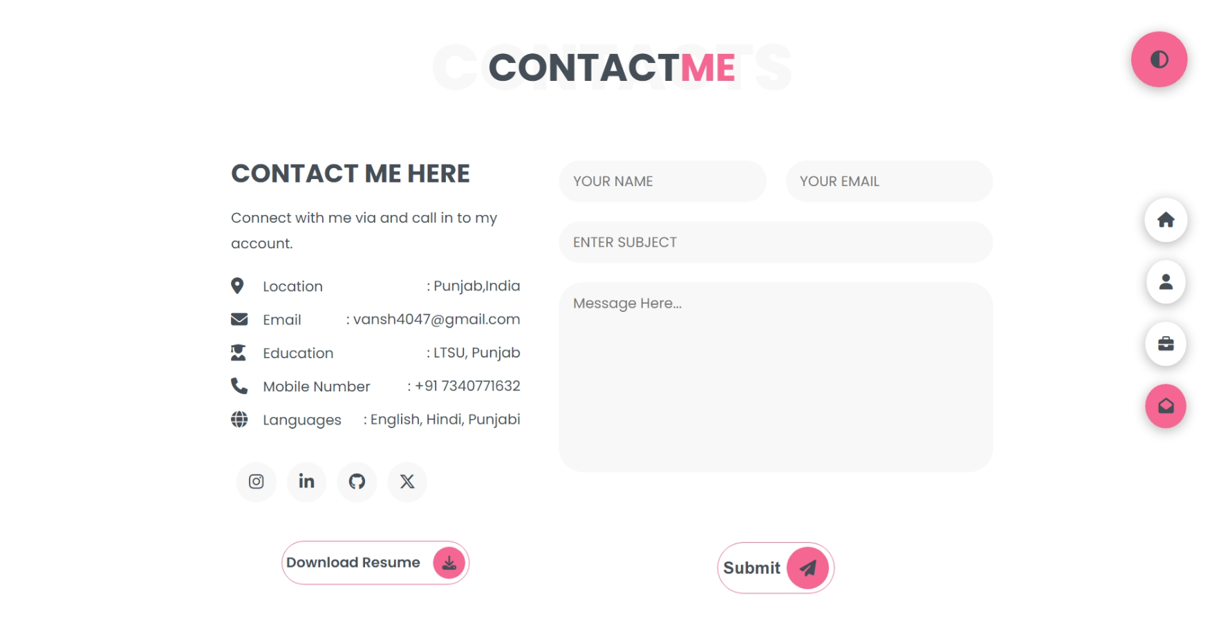

### **CHAPTER 11: CONCLUSION**

## 11.1 Summary of the Project

This project successfully resulted in the development of a personal portfolio website. It showcases my skills, projects, and professional achievements in a clean, responsive, and user-friendly interface. The website has been fully tested to ensure it meets the functional requirements and provides a positive user experience across multiple devices.

## 11.2 Contributions and Implications

This project has allowed me to apply and deepen my understanding of web development technologies, including HTML, CSS, JavaScript, and SCSS. It has also enhanced my skills in responsive design, user interface creation, and JavaScript validation. The portfolio website is now a part of my professional profile, serving as a testament to my technical abilities and an essential tool for connecting with potential employers or clients.

## 11.3 Future Work or Improvements

In the future, I plan to enhance the portfolio website by:

* Adding a backend for handling contact form submissions.
* Integrating a blog and certification section to provide ongoing content and project updates.
* Exploring CMS integration to simplify content management.

### **CHAPTER 12: REFERENCES**

* <https://www.w3schools.com/css/css_navbar_vertical.asp>
* <https://developer.mozilla.org/en-US/docs/Web/CSS/CSS_transitions/Using_CSS_transitions>
* <https://developer.mozilla.org/en-US/docs/Web/CSS/filter>
* <https://developer.mozilla.org/en-US/docs/Web/API/EventTarget/addEventListener>
* <https://developer.mozilla.org/en-US/docs/Web/HTML/Element/a#target>
* <https://developer.mozilla.org/en-US/docs/Web/HTML/Element/input>
* <https://developer.mozilla.org/en-US/docs/Web/CSS/transform>
* <https://www.w3schools.com/cssref/pr_class_position.php>
* <https://developer.mozilla.org/en-US/docs/Web/CSS/box-sizing>
* <https://sass-lang.com/documentation/style-rules/#nesting>
* <https://sass-lang.com/documentation/style-rules/>
* <https://developer.mozilla.org/en-US/docs/Web/JavaScript/Reference/Functions/Arrow_functions>
* <https://developer.mozilla.org/en-US/docs/Web/JavaScript/Reference>
* <https://developer.mozilla.org/en-US/docs/Web/CSS/Reference>
* <https://developer.mozilla.org/en-US/docs/Web/HTML/Element>
* <https://www.w3schools.com>
* <https://developer.mozilla.org/en-US/docs/Web/HTML/Element/form>
* <https://developer.mozilla.org/en-US/docs/Web/CSS/flex>
* <https://sass-lang.com/documentation/style-rules/declarations/>
* <https://sass-lang.com/documentation/syntax/structure/>

* <https://developer.mozilla.org/en-US/docs/Web/CSS/grid-template-columns>
* <https://developer.mozilla.org/en-US/docs/Web/API/DOMTokenList/toggle>
* <https://fonts.google.com/specimen/Poppins>
* <https://fontawesome.com/search>
* <https://developer.mozilla.org/en-US/docs/Web/CSS/z-index>
* <https://developer.mozilla.org/en-US/docs/Web/CSS/box-shadow>
* <https://developer.mozilla.org/en-US/docs/Web/CSS/animation>
* <https://developer.mozilla.org/en-US/docs/Web/CSS/@keyframes>